**2023 North Island Championships   
& Waimarino Trophy***Day 1 - Giant Slalom*

**DATE:** Saturday 19th August, 2023

**SCHEDULE:**

* **8.00am** (approx.) - Sky Waka opens for access to Knoll Ridge Café
* **8.30am-9.15am** – Bib collection (downstairs of Knoll Ridge Café at top of Sky Waka)
* **9.30am-10.00am** - Course inspection (from top of the Valley T-Bar)
* **10.15am** – Race 1 start (Waimarino Trophy)
* **TBC** (updates on WhatsApp) – Course inspection (from top of the Valley T-Bar)
* **TBC** (updates on WhatsApp) – Race 2 start (North Island Champs)
* **TBC** (updates on WhatsApp) – Prizegiving outside Lorenz’s Bar & Café (bottom of Sky Waka)

**RACE COURSE:** Whakapapa Valley (accessed via Valley T-Bar)

**CATEGORIES:** Male / Female - U8 / U10 / U12 / U14 / U16 / U19

**FORMAT**: Giant Slalom  
 2 x One-run races

**RACE ENTRY: $35 per athlete**

**LIFT PASSES:** 50% Discount on Day Passes for registered athletes (to be purchased on the day from Whakapapa Guest Services)

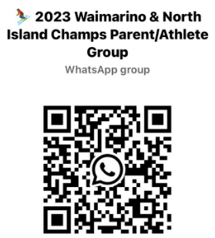**REGISTRATION:** [www.snowsports.co.nz](https://www.snowsports.co.nz/calendar-and-results/2020-events-calendar-and-registration/snowplanet-junior-interfield/) - Registrations close midday on Thursday 17th August.  
*\*All athletes are required to be a registered member of Snow Sports NZ. Registration is free for athletes aged under 16.*

**TCM:**Team Captains meeting will be Friday 18th August at 6.00pm. Location to be confirmed (will be notified on WhatsApp group)

**COMMUNICATIONS:** Please join the following WhatsApp group for pre-event and event day updates - <https://chat.whatsapp.com/DefXp2cLsa9AyxNLvcr8JL>

**ROC**: Northern Ski Team

**Technical Delegate**: Ken Jackson  
**Referee**: TBC  
**Chief of Race:** Adrian Farnsworth  
**Chief of Timing:** Laura Jackson  
**Race Secretary:** Duane Barakat - [theteam@northernskiteam.co.nz](mailto:theteam@northernskiteam.co.nz)